Exercise #01

Food Delivery Home Screen

Android Developer Bootcamp

🎯 Purpose
Create a modern Food Delivery Home Screen using XML layouts in Android. This exercise helps you practice using multiple layout containers to build a real mobile application interface.

🧩 Problem
Design a Food Delivery App Home Screen that contains:

Header Section
- App Logo (ImageView)
- App Name: "FoodExpress"
- Delivery Location Text

Food Categories Section
Display four food categories:
- Pizza
- Burger
- Biriyani
- Desserts
Each category should contain:
- ImageView
- Category Name

Popular Foods Section
Display three food cards:
- Chicken Biriyani
- Zinger Burger
- Pepperoni Pizza
Each card should contain:
- Food Image
- Food Name
- Price

Action Section
Add two Buttons:
- Order Now
- View Menu
The screen should be scrollable, well organized, and visually appealing.

How to Solve
- Create a new Android project.
- Use a ConstraintLayout as the root layout.
- Add a ScrollView to support vertical scrolling.
- Place all sections inside a vertical LinearLayout.
- Create a header section containing the logo and app information.
- Add a GridLayout with two columns for the food categories.
- Create food item cards using LinearLayouts.
- Add ImageViews, TextViews, and Buttons where required.
- Apply proper padding and margins between sections.
- Use suitable text sizes and styling to improve the UI.
- Run the application and verify that the layout is displayed correctly.

You Will Achieve
- ConstraintLayout – Creating a flexible root container.
- ScrollView – Making large screens scrollable.
- LinearLayout – Organizing sections vertically.
- GridLayout – Arranging category cards in a grid structure.
- TextView – Displaying headings and content.
- ImageView – Displaying food and category images.
- Button – Creating interactive UI elements.
- Margin and Padding – Improving spacing and readability.
- Layout Attributes – Understanding width, height, gravity, orientation, and spacing.
- UI Design Principles – Building a modern application home screen.

Screenshots
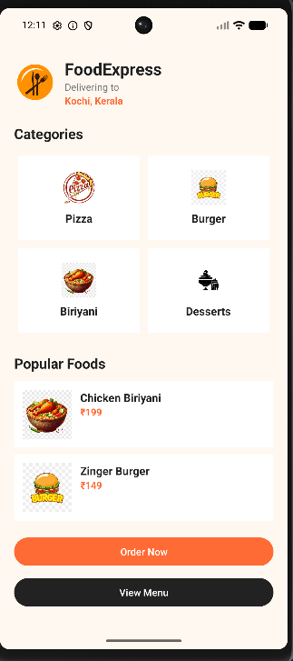

How to Upload
git add .
git commit -m "Completed exercise"
git push origin <your-branch-name>

